Shabbos Stories
For Parshas tazria 5784
Volume 15, Issue 33 5 Nisan 5784/April 13, 2024
Printed L’illuy nishmas Nechama bas R’ Noach, a”h
For a free subscription, please forward your request to keren18@juno.com
Past emails can be found on the website – ShabbosStories.com
Is That Woman Your Grandmother?
By Rabbi Yechiel Spero

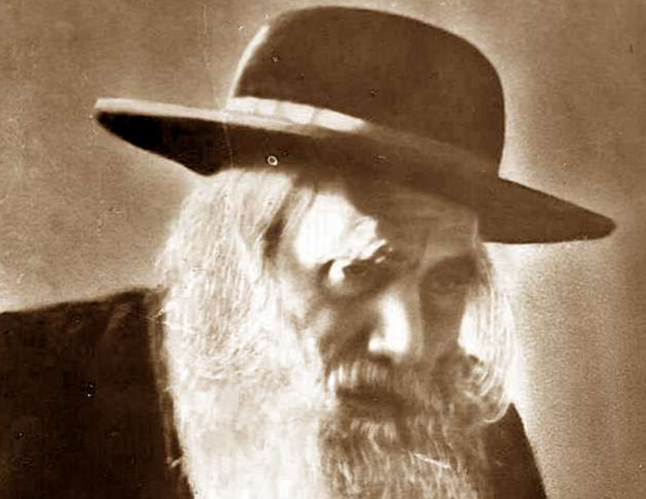

Every Shabbat, the young men from the yeshivah in Pressburg would eat their meals at the homes of members of the community. After praying, they would emerge from the bet midrash en masse and walk through the town to their respective hosts’ homes. Every week, one of the young men would wander off by himself for a while, and then catch up with the group a few blocks away. This young man, Chaim, was well respected among his peers as a caring, generous individual, always ready to help a friend in need. Chaim’s “disappearing act” intrigued his friends, and they decided to follow him one week to see where he went.

Knocking Gently on the
Basement Apartment Door
The next Shabbat morning, the boys followed Chaim into a particularly poor part of town. Chaim walked to a basement apartment and knocked gently on the door. An old woman answered and Chaim wished her a warm Shabbat Shalom. Seeing the smile on her face, they assumed that this was his grandmother. They managed to get away before he could see them, but when he rejoined the group, they confessed that they had followed him. “So,” they asked, “who is that woman? Your grandmother?”
A bit embarrassed that he had been caught in the act, Chaim shyly responded that the woman was not even related to him. That piqued their curiosity even more. “Then, Chaim, why do you go wish her a Shabbat Shalom every week?”

This Woman is a Widow
By this time a bigger crowd had gathered, with everyone eager to hear Chaim’s story. “The truth is that this woman is a widow, and she had very little family around. So, I figured I would go to wish her a Shabbat Shalom. She seems so happy when I come and it is such an easy thing to do - How could I not?”
The stunned friends hung their heads in humility. Amazed that their young friend had the sensitivity to look after an old widow, they knew then that this boy would become something special.

“The Bachur is Coming! The Bachur is Coming!”
Rav Yitzchak Shloime Blau remembered this story fondly because he was a little boy at the time and the old woman was his grandmother. “And although I was only six or seven years old, I remember waiting outside for him every Shabbat and then running inside to tell my grandmother, “The bachur is coming! The bachur is coming!”
Chaim’s friends were correct in predicting that this young man was destined for greatness. Young Chaim grew up to become the great Rav Yosef Chaim Sonnenfeld, Rav of Yerushalayim! (Touched by a Story 3)

Reprinted from the Parashat Vayakhel 5784 email of Rabbi David Bibi’s Shabbat Shalom from Cyberspace.

The Son of the Rav of Vienna – Part Two
By Yair Weinstock

The king sent a written message to R’ Shlomo, stating that his daughter refuses to marry anyone other than his son, Yitzchak. He notified R’ Shlomo that a servant will soon come to bring his son to the king.
R’ Shlomo broke into bitter weeping. The Rebbitzen almost fainted. How could they refuse the king’s decree; yet how could they let their son marry a gentile woman? Friends and neighbors offered ideas and advice. Tuvia, head of the community, told them, “The princess wants your unmarried son. But she would not want him if she knew he was married…”

All the Respectable Suggestions Seemed to Have Disappeared
They realized that Tuvia was right. They quickly began searching for an appropriate girl for Yitzchak to marry post haste. All the respectable suggestions seemed to have disappeared, yet they needed to marry him off immediately. Then they thought of Bluma, the maid, who was not particularly beautiful, did not come from lofty lineage, had no money and no parents. She possessed only one important trait – she was an available unmarried Jewish girl.
A minyan was called together and a hasty chuppah was swiftly arranged. In their worst nightmares, R’ Shlomo and his wife had never dreamed that their splendid son would marry a simple and homely maidservant in a swift and somber ceremony! A few days later, R’ Shlomo understood the wisdom of Tuvia’s advice. The king sent soldiers to summon Yitzchak, so that he could be taught to become a good Christian as preparation for his marriage to Princess Wilhelmina.

Brought Proof that His Son Was a Married Man
When R’ Shlomo stated that his son was a married man, and brought proof of this fact, the decree was annulled. Several weeks later, when it was clear that the danger had passed, the rebbetzin told Bluma that she should now accept a divorce from her son, as it had only been an emergency arrangement. Bluma refused; she claimed that her marriage was a proper one and she would not give it up!
The rebbetzin then called Yitzchak and commanded him to give his wife a divorce, as she was not his proper partner. Yitzchak would not hear of it either. “This was destined in heaven,” he said. “Hashem checked all the matches, examined all the factors, and caused this to happen, because in the natural way there would have been no chance of the rabbi’s son marrying the maidservant Bluma.”
His mother cried to him, “Yitzchak, are you mad? The greatest in the land are nothing compared to you, and you will stay tied to a homely maid?!?”
Yitzchak replied, “Yes. I prefer to be tied to the maidservant, who is beautiful in my eyes, rather than humiliate a Jewish woman.” At that moment, a great furor broke out in heaven, and the Heavenly Tribunal judged that Yitzchak should be granted a great gift. Bluma bore Yitzchak 24 children, all beautiful, sensitive and successful – 12 pairs of twins! And from these twins came the famed Teomim (twins) [or Thumim] family, spread in communities around the world.

Reprinted from the Parshas Pekudei 5784 email of The Weekly Vort. Excerpted from the ArtScroll book – “Tales for the Soul” by Yair Weinstock.

Going Beyond
One’s Obligation
By Rabbi Yoni Schwartz

There was an incredible woman who started a charity organization to help young cancer patients by taking them on fun trips, bringing them entertainment, and doing everything possible to bring joy into their lives. When a potential donor, Reuven, saw how much she sacrificed each day to keep the organization running, he asked her why she dedicates nearly her whole life to this cause.
She explained that for years she was childless. When she went to Rav Shlomo Zalman Auerbach, ZT”L, for a bracha to have kids, he told her that this was not decreed for her in Heaven. If she wants something from Hashem that isn’t decreed for her, she then must do something beyond her obligation.
She continued explaining to Reuven: “the day that I opened this organization, I conceived. Two years later when I expanded it, I had another child and two years after that, during my second expansion, I gave birth to a third child.
Being childless, Reuven got so inspired that he decided to similarly undertake something above and beyond. With his wife’s consent, he put his name on a kidney donation list. Right after signing up, after sixteen years without children, his wife conceived. A few days before the Bris, he was notified that a match was found for his kidney and he donated it, saving somebody’s life.

Reprinted from the Parshas Pekudei 5784 email of Torah Sweets.
A Time to Post Signs and a Time Not to Post Signs

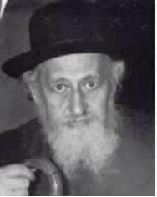

In the town of Brisk there were elections for the board of the Jewish community. On one side was the Brisker Rav and those that were following his rulings. On the other side were a group of people looking to ease off on all religious laws. They wanted to remove the Rav's Kashrus certificate from the butcher, stop the funding for the Jewish education and much more.
The campaign was run mainly by posting up signs in the streets and in the Shuls. Each side explained the importance of their view and what was wrong with the other party. The elections were to take place on Motzaei Shabbos. The last signs were going to go up on Friday.
The Rav's followers went over the last sign and what had to be highlighted just before the elections. The paper was given in to the printer to be printed. Shortly after a copy of their sign was given to the other party. There was a massive uproar. Every word of the Rabbis sign was so true and convincing.
The other party decided to prepare a sign fiercely attacking the religious party very sharply. The sign personally attacked the Rav, the candidates and everything they stood for. The printer had a difficult job getting ready two signs in time for Shabbos. In those days every letter had to be put on a massive plate until the whole page was ready. It wasn't a quick job.
The posters arrived late Friday afternoon. They brought one to the Rav to show him. He asked where were the rest of the posters? He asked to see them all. He took all of them and put them in his study. His supporters were in shock.
The Rav explained that since it was late it was inevitable to hang up the posters before Shabbos and therefore it would involve desecration of the Shabbos. They tried to explain to the Rav that for sure the opposing party had prepared very powerful posters and it was very important to voice their opinion. The Rav didn’t budge. And as everyone went to Shul they all stopped to read the posters being hung up as Shabbos had already come in.
The posters were so sharp and so belittling the Rav; the local townspeople were in total shock. Why such behavior against the Rav? So much so that they were so angry most of them voted in favor of the Rav's candidates.
Had the other signs gone up on the walls everyone would have understood that one sign was answering back against the other. But now there was no valid reason for such behavior. So, in the end by listening to the Brisker Rav and being extra careful to keep Shabbos ended playing in their favor.

Reprinted from the Parshat Pekudei 5784 email of Rabbi Dovid Caro’s Inspired by a Story.
Talking to the Ribono
Shel Olam at the Kosel

Rav Yeruchem Silber, who learned in Rav Yisroel Zev Gustman’s Yeshivah in Eretz Yisroel for six years, shared a story that he heard from Rav Gustman himself. A few years before Rav Gustman opened his Yeshivah, he went to see the Tchebiner Rav, zt”l, to ask him for guidance about opening the Yeshivah, and he said that he wanted to open it in the Geulah neighborhood.
The Tchebiner Rav indeed advised Rav Gustman to open a Yeshivah, but surprisingly, he told him not to open it in Geulah. He said, “Geulah doesn’t need another Yeshivah, but Rechavia does. Go build a Yeshivah there, and bring Torah to that neighborhood.”
The cost to purchasing a building in Rechavia was significantly higher than in Geulah. Buildings were almost four times higher there. The Tchebiner Rav gave him a Brachah that he will be successful in this endeavor.

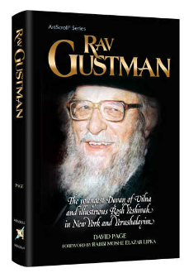

Rav Gustman told Rabbi Silber, “What did I do? I went to the Kosel and spoke to the Ribono Shel Olam. I said, ‘Ribono Shel Olam, the Gadol HaDor, the Tchebiner Rav, advised me to buy a building in Rechavia and open a Yeshivah there. The Rambam writes at the beginning of his work that everything is from You, and the words of the Gedolim are really Your words. Hashem, I have a dilemma. I can buy a building for the Yeshivah in Geulah for $40,000, or I can buy in Rechavia where it costs $150,000. The Tchebiner Rav told me to purchase the one in Rechavia, so that means that You say so as well, correct?’” Rav Gustman waited a moment before continuing.
“All right, Hashem, Your silence means that You agree! However, I have no idea where the money for this will come from. But the truth is, Ribono Shel Olam, the money is all Yours, and since You agree with the Tchebiner Rav that I should open a Yeshivah, I suppose that means that You will help me find the means to purchase it. Wherever I open a Yeshivah, it would only be because it is You Who would be giving me the means to do so. So please, Hashem, I ask You to please help me follow the direction of the Tchebiner Rav!”
With that, Rav Gustman walked away, completely content with his request from Hashem, and within days, he had the money he needed for the building of his new Yeshivah, Netzach Yisroel, in Rechavia!

Reprinted from the Parshas Pekudia 5784 email of Rabbi Yehuda Winzelberg’s Torah U’Tefilah.

How to Control Your Temper

Rav Dovid Orlofsky said that one time a friend of his told him about when he was waiting on a line in a store, and the person who was in front of him was dissatisfied with something the shopkeeper had done. This fellow then took the ‘obvious’ next step, and he started screaming at the shopkeeper in a blazing fit of rage, until he was literally red in the face from his furious shouting.
“However,” Rabbi Orlofsky said, “to my friend’s great surprise, no matter what the customer said to him, the guy behind the counter just wouldn’t get upset. Not a twitch of reaction could be seen on his face. He just sat there calmly taking it all in.
My friend was shocked. He had never seen such calm, such reserve. ‘How did you do that?’ he asked the shopkeeper after the incident had ended, and the angry customer had left. ‘How can you take that type of aggravation and not get upset?’
The shopkeeper looked up at him and explained, ‘It’s simple. I have a very serious heart condition. Without exaggeration, If I get upset, I could die. It’s just not worth it to me.’”
Rav Orlofsky said, “What a powerful lesson! If we are given such choice, between controlling our anger or facing dreadfully dire consequences, then we can find a way to maintain that extreme level of control. We just need the push that will help us get there, but we can do that is every situation we find ourselves in as well!”

Reprinted from the Parshas Pekudia 5784 email of Rabbi Yehuda Winzelberg’s Torah U’Tefilah.

Never Stuck!
By Rabbi Heshy Kleinman

A couple complained to their rebbe that they were “delayed and stuck somewhere” for Yom Tov. He assured them, “A Jew is never stuck. A Jew is sent. Wherever you are — you have been sent there. Wherever a Jew is, he is where he is supposed to be.”
As the Gemara states, our footsteps are Divinely guided. We’re led to where we’re summoned. Every situation, every encounter, is masterfully orchestrated by Hashem for a purpose. We were put in that place, along with the people who are there with us, for a reason.

Her Seatmate on the Plane
was a Non-Jewish Woman
Hashgachah Pratis: Dovid Gross was a teenaged boy who was enrolled in a summer camp in Cleveland. Unfortunately, he ended up in a hospital bed, miles from his home, suffering from ulcerative colitis. Feeling nervous, Dovid’s mother, Leah, went to see him. She sat down on the plane next to her seatmate, a non-Jewish middle-aged woman, Abbey.
Uncharacteristically, Leah opened up to a total stranger. “I’m on my way to see my teenage son, who was just diagnosed with an acute case of ulcerative colitis,” she said.

A Nurse Working for a Doctor
Specializing in Ulceratie Colitis
Abbey’s mouth dropped open. “You will never believe it, but I am a nurse practitioner for a doctor who specializes in ulcerative colitis. I see patients with this disease every day,” she told Leah. Leah was stunned. They spent the rest of the flight with Leah asking questions and Abbey walking her through the treatment options. Most of all, she stressed that ulcerative colitis is a chronic illness, but she had seen many patients recover and go on to lead healthy lives.
Just before the plane arrived in Cleveland, Leah asked Abbey, “How did you end up on this flight?” Abbey smiled. “I wasn’t even supposed to be on this flight. I worked in the Cleveland Clinic for years and I was going back to visit my family in Cleveland for the weekend. However, my mother wasn’t feeling well, so I re scheduled my ticket for today.

Normally the Nurse Doesn’t
Chat with People on Plane Flights
“More surprising, I hardly ever chat with people on a flight. I usually catch up on my sleep. But when I sat down next to you, you kind of looked stressed out, so I thought I would just try to calm you down a bit.”
Before the two women went their separate ways, Leah thanked Abbey and said a special thanks to Hashem for sending a nurse out of nowhere to calm her and give her vital information. As she got into her rented car, Leah began to cry — no longer tears of fear, but tears of thanks and connection to Hashem.
“Thank You, Hashem,” she said. “Thank You for reminding me that I am never alone.”
Even in the face of death, we can find Hashgachah Pratis. The Midrash explains that one might die away from home not by chance, but because his death will perhaps strengthen the faith of those in that town. Whatever the reason, Hashem creates the circumstances for that to occur.

“A Person’s Feet Are His Guarantors
Hashgachah Pratis: Rav Avrohom Pam shared his personal experience when his mother passed away while his Rebbetzin was in Lakewood for the birth of a grandchild. It was unusual that she did not return home the same day she went to Lakewood. Although some speculated that emergency room delays had caused his mother’s death and that Rebbetzin Pam’s presence may have helped to speed things up, Rav Pam found solace in knowing that it was predestined, a manifestation of the Gemara’s wisdom:
“A person’s feet are his guarantors; to where he is summoned, there they lead him.” In each of life’s journeys, we can find reassurance in the knowledge that we’re never lost, but are guided by Hashem. Each twist, each turn, is a chance for a loving connection, an opportunity for spiritual growth, and a manifestation of Hashem’s plan.

Reprinted from the Parshas Pekudei 5784 edition of At the ArtScroll Shabbos Table. Excerpted from the ArtScroll book -- Living with Hashgachah Pratis by Rabbi Heshy Kleinman.

How to Raise Money
for Charity
By Rabbi David Bibi

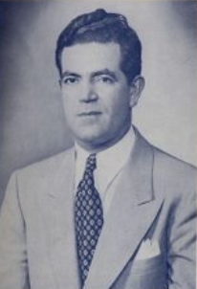
Mr. David Bibi

Our dad would tell us about his uncle Dave Bibi who at a very young age was appointed President of Ahi Ezer and who was involved in so many charities within the community and beyond. He ran a very successful business and was partners with our grandfather, his brother Reuben, who designed and ran the manufacturing and his nephew Nouri Dayan, who took care of billing, collections, payables and ran the office.
Dave was the salesman and often the face of the company and was always busy. Yet one day each week was set aside for charity collecting. With whomever he was partnering with on the project, he set aside time and went office to office downtown, visiting the community businessmen and presenting the needs for each endeavor.
Sometimes he went with Mr. Mousa Mann, other times with Mr. Isaac Escava and other times with Mr. Isaac Shalom. These were some of the most important members of the community and they never saw it beneath themselves to go out collecting. And imagine if you were the one they came to visit. How could you not help? These important men left their office to come see you. How could you turn them away.
But more importantly, they set the example for everyone else and were always the first to donate.

Reprinted from the Parashat Vayakhel 5784 email of Shabbat Shalom from Cyberspce.

The Young Man
with the Ugly Scar
By Rabbi Reuven Semah

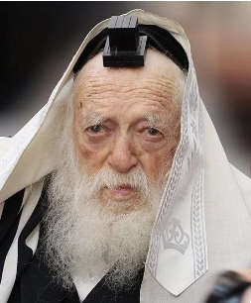

Rabbi Yitzchok Hisiger tells a truly amazing story. During the hours that Rav Chaim Kanievsky zt”l dedicated for people to see him, he was visited by a young man. He came to talk to Rav Chaim because he was having difficulty in finding a shidduch. While speaking he pointed out the obvious: a large scar marred his face.
“This is probably the reason I get so many rejections,” he said despondently.
“How did you get this scar?” Rav Chaim asked, compassion in his eyes.
The young man responded that a few years earlier, he was in the Old City of Jerusalem and saw an Arab chasing a Jewish girl. He pursued the Arab and a scuffle ensued. During the fight, the Arab stabbed his face repeatedly, and when the wounds healed, his face was permanently scarred.
“When the next shidduch is arranged for you, tell the girl how you became scarred,” Rav Chaim advised.
The young man followed these instructions, and upon the conclusion of his recital, the girl asked for more details about the incident.
Finally, visibly moved, she exclaimed, “I am that girl – the one you saved! Ever since that day, I have wanted to find you and thank you for saving me.”
The two got married and the young lady became very close to Rebbetzin Batsheva Kanievsky.
“If a shidduch is bashert (i.e. nassib),” Rav Chaim would conclude after repeating this story, “Hashem works a unique chain of events to bring it to fruition.”
Hashem does not forget a courageous act.
Shabbat Shalom. Rabbi Reuven Semah

Reprinted from the Parashat Vayakhel 5784 email of Shabbat Shalom from Cyberspce.

A Sense of Justice
By Rabbi Paysach J. Krohn

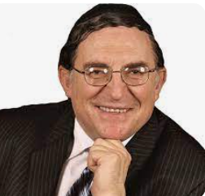
Rabbi Paysach J. Krohn

One Shabbat afternoon, shortly after a noted Talmid Hacham had been appointed Rav of Brisk, in Lithuania, a police official appeared at his home. He informed the Rav that one of the Jews being held in the local jail had been sentenced to death and that as the new official clergyman for the Jews in Brisk, he was obliged to come and say confession with the man. He went on to explain that official rules dictated that every man, regardless of his religion, be given the opportunity to speak with a clergyman of his faith one last time before his execution.
The Rav told the officer that he was sorry but he could neither comply nor go along with him. The officer was surprised by the refusal. "What do you mean you won't come?" snapped the officer. "Every clergyman always goes for the sake of the people of his faith. Why won't you go?"

“I Don’t Want to Be a Cause for His Death
The Rav explained, "You say that the law states that a man cannot be executed until he meets with his clergyman. Thus, as long as I don't go, he can't be put to death. I don't want to be a cause in his death, for once I go, I have, in essence, removed the last barrier to his execution."
The officer was at first intrigued by the Rav's reasoning, but he soon became outraged. But the more he argued, the more he realized that the Rav wouldn't budge from his position, so the officer went back to his headquarters.
Word of the Rav's refusal quickly spread through the town and soon a crowd gathered at his home. They wondered if he wasn't putting the Jews of the town in jeopardy, because his refusal to cooperate with the authorities would only antagonize them and add to the hatred they already had for the Jews. Some even criticized him for a lack of compassion, noting that he was a young and inexperienced man himself.
Later, a police lieutenant and a few underlings arrived at the Rav's home. He came straight to the point. "I demand that you come with me at once," he ordered. "We have business to take care of and we can't be bothered with your nonsensical reasoning. You are to return with me immediately."

Refused to Be Scared by the Lieutenant’s Threats
Not impressed by the lieutenant's bluster, the Rav explained calmly once again that according to his understanding, he could not go to say the confession, for he would not be even an indirect cause of a fellow Jew's death. The lieutenant threatened to drag the Rabbi to the jail and put him in the same cell with the prisoner. The Rav stood his ground and would not go. Some people tried to send the shul attendant to take the Rav's place, but the lieutenant would settle for nothing less than the Rav.
When he came back to headquarters, the lieutenant ordered that the death of the criminal be delayed until he received further instructions from higher authorities.
That night an envoy came from a higher court with an order stating that the Jewish "criminal" had been pardoned. Thus, a man's life was saved only because the new Brisker Rav refused to have any part, no matter how slight or indirect, in bringing about the death of a fellow Jew.

Reprinted from the ArtScroll book –"The Maggid Speaks” by Rabbi Paysach J. Krohn. (Editor’s Note: To see a photo of the Brisker Rav, turn back to page 5).

